Part-Aware Dynamic Memory Alignment for DM-GAN
  - A Controlled Evaluation on CUB-200-2011

Final Project Report · Group G_
Course: HSDS-501001
Wenzhe Cao · Jikui Zhou · Xinyi Jiang · Zhongyu Yin
2 September 2026

Final answer: superiority was not demonstrated under the controlled protocol.

1. Introduction
Text-to-image synthesis must satisfy two goals at once: the image should look plausible, and its visual details should match the caption. Generative adversarial networks provide the adversarial learning framework [5], while multi-stage systems such as StackGAN improved resolution by refining a coarse image [6]. Fine spatial binding nevertheless remains difficult: a model may reproduce the requested colours while attaching them to the wrong bird part. DM-GAN addresses this problem through dynamic memory: it generates a 64 × 64 image, rewrites a memory from caption words according to the current visual state, and then refines the image at 128 × 128 and 256 × 256 [1].
Our Session 6 work first established a credible baseline. The author-released CUB generator and frozen DAMSM encoders were loaded into a modern PyTorch implementation and evaluated on 30,000 fixed samples. The run produced FID 15.7576 and DAMSM R-precision 76.67% ± 0.83%, close to the released references of 15.34 and 76.58% ± 0.53% [8]. ImageNet Inception Score was retained only as a health check and was not compared with the paper's legacy bird-classifier score [7]. This supports checkpoint, inference, and evaluator compatibility; it does not claim that a 200-step random-initialized run had converged.
The final project asks whether landmark supervision can improve fine-grained placement. We added a part-aware alignment loss using the 15 annotated CUB bird landmarks [2]. The research question is deliberately narrow: under paired initialization and equal training budget, does the part-aware branch improve an output-level part–colour diagnostic while preserving global quality? A lower auxiliary loss alone is insufficient, because an internal attention map can move toward its target without improving the generated pixels. Our contribution is therefore both an implementation and a controlled test whose conclusion is allowed to be negative.

2. Project Construction

2.1 Baseline pipeline
CUB-200-2011 contains 11,788 images from 200 bird species, with bounding boxes, attributes, and 15 part locations [2]. DM-GAN metadata supplies splits, ten captions per image, vocabulary indices, and class identifiers. Images are cropped around the bird, resized, randomly cropped and flipped, normalized, and downsampled to 64, 128, and 256 pixels. The frozen DAMSM encoder provides word and sentence embeddings [3]. The generator combines conditioning augmentation, an initial stage, two dynamic-memory refinements, and three image heads; conditional and unconditional discriminators operate at all three scales.

2.2 Part-aware alignment
The extension converts each visible part coordinate into a normalized Gaussian heatmap on the attention grid. Generic words such as “wing,” “eye,” and “leg” combine left/right landmarks. Because CUB has no head point, “head” is fixed as crown, forehead, nape, and visible eyes; beak and throat remain separate. A dictionary links part nouns to targets, and a nearby colour or pattern token inherits the nearest part noun within four tokens. This rule is reproducible but cannot resolve every grammatical ambiguity.
Ltotal = LDM-GAN + λpart Lpart, λpart = 0.05
The cross-entropy term penalizes attention far from its heatmap and is averaged across both refinement scales. Coordinates undergo the same bounding-box crop, resize, random crop, and horizontal flip as the image; invisible or out-of-crop points are masked. Without this synchronization, the extra label would supervise the wrong location.

2.3 Controlled Experiment and Evaluation
The experiment used three paired seeds: 20260824, 20260825, and 20260826. Each pair started from the same released generator. Because the released package does not provide matched discriminators, the generator was frozen while a discriminator set was warmed for 200 steps; that discriminator and optimizer state were then cloned into both branches. B was the baseline control with λpart = 0. C was identical except for λpart = 0.05. Both received the same data batches, captions, augmentations, latent noise, frozen DAMSM encoders, batch size 10, and 1,200 updates. Only the 128/256 refinement stages and image heads were trainable in both arms. Final EMA weights were evaluated, so checkpoint choice did not depend on appearance.
Each of the six checkpoints generated 30,000 paired test samples using evaluation seed 20260902, identical captions, latent noise, and negative captions. The 29,330-caption bank wraps once, so 670 caption positions repeat with different generated noise. FID measures global feature-distribution quality [4], and official DAMSM R-precision measures whether the correct caption ranks above 99 different-class captions. The targeted diagnostic keeps the part noun fixed and asks whether a generated image ranks its correct colour caption above nine colour-swapped alternatives. It produced 24,924 eligible evaluation rows per model. Landmark-attention cross-entropy and support mass were recorded only as mechanism proxies.
Before results were inspected, superiority required four conditions: the 95% cluster-bootstrap interval for the part–colour delta had to lie above zero; mean FID regression could not exceed 1.0; R-precision regression could not exceed 1 percentage point; and at least two of three seeds had to improve the targeted score. All deltas are C − B. This design isolates the added objective from continued fine-tuning, while acknowledging that C consumes extra landmark supervision and that the test is controlled fine-tuning rather than full training from scratch.

3. Results
Global quality remained essentially stable. Mean FID moved from 16.0544 for B to 16.0902 for C, a paired change of +0.0358 (higher is worse). Every seed moved slightly upward, but the mean regression was far below the 1.0 safeguard. Mean R-precision moved from 78.0833% to 78.1322%. The pooled paired effect was +0.0489 percentage points with a 95% cluster-bootstrap interval of [−0.0495, +0.1551]; the aggregate McNemar test was not significant (p = 0.3537). These results pass the non-regression gates but do not demonstrate global improvement.
The primary part–colour result did not improve. Mean accuracy changed from 72.4844% to 72.4322%, a paired effect of −0.0522 percentage points with a 95% interval of [−0.1488, +0.0537]. The interval crosses zero, and the pooled McNemar test was also non-significant (p = 0.3270). Across seeds, the changes were +0.044, −0.020, and −0.181 percentage points. Only one of three seeds moved in the desired direction, so both targeted success conditions failed.
The auxiliary mechanism did respond to training. Part-attention cross-entropy fell from 11.25537 to 11.24990 (Δ = −0.00547; 95% interval [−0.00557, −0.00544]). Yet attention mass inside the annotated 10% support changed by only +0.00088 percentage points. This is the central result: the directly optimized proxy improved slightly, but that change did not transfer to the output-level part–colour behaviour. Fixed, unfiltered B/C image grids likewise show very subtle differences rather than a reliable visual winner. Under the predeclared rule, the answer is therefore not demonstrated, not “proved impossible.”
The result is a valid negative finding for this configuration: λpart = 0.05, Gaussian width 8% of the grid, restricted refinement-stage fine-tuning, 1,200 updates, three paired seeds, and CUB. It should not be generalized beyond this scope.

4. Conclusion and Future Work
This project reproduced the released DM-GAN baseline through a modern inference and evaluation path, implemented synchronized landmark supervision, and compared it against an equal-budget control. The baseline evidence is credible, the added loss is active, and the paired design avoids the invalid comparison of a fine-tuned model with an untouched checkpoint. Nevertheless, the tested part-aware method was not shown to be better: FID changed only slightly, R-precision was stable, and the primary part–colour effect was small, negative on average, and uncertain.
Several limits qualify the conclusion. The study fine-tuned official weights rather than training both models for the original full schedule; discriminators were locally warmed; only three seeds were available; and C used extra CUB labels. The real-image landmark can also disagree with the pose chosen by the generator. The colour-swap test uses the same frozen DAMSM family as training, while FID does not measure localization. Finally, heuristic token-to-part rules can misread captions. These limits do not justify relabelling a null result as success; they identify the next experiments needed.
Future work should first use an independent generated-image evaluator: a frozen bird-part detector plus attribute classifier, or a blinded paired human study with at least three raters. A longer schedule and at least five seeds should estimate retraining variance. Hyperparameters—loss weight, Gaussian width, token window, and trainable module scope—should be selected only on a validation split and all tried settings disclosed. A generated-image keypoint detector could make the spatial target pose-adaptive, and multi-noise diversity metrics could test whether added supervision collapses pose variation. Until such evidence produces a positive output-level effect, the defensible final conclusion remains that part-aware superiority was not demonstrated.

Figures and Tables
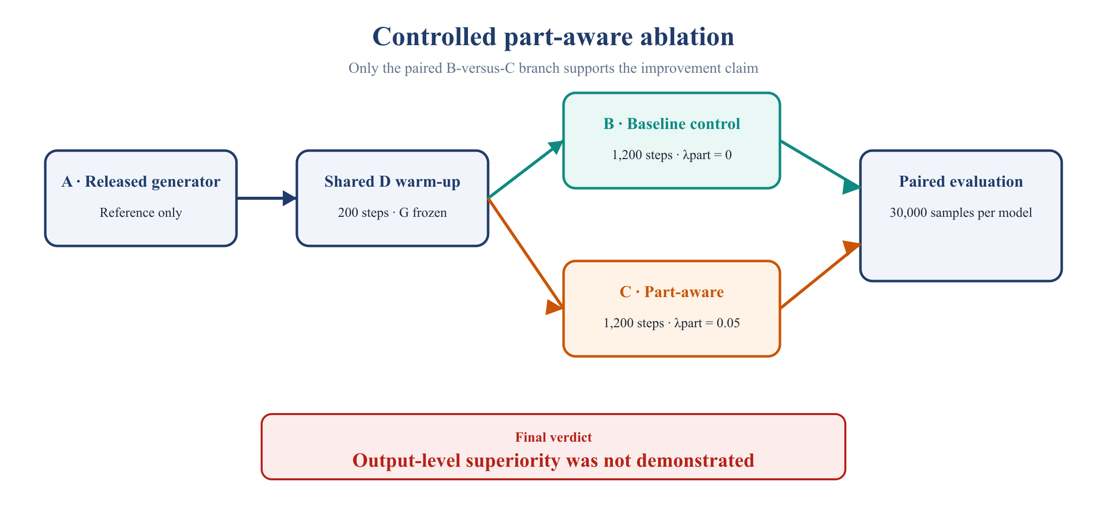
Figure 1. Controlled ablation. Only B versus C isolates the added part-aware objective.
Seed | B FID | C FID | Δ FID | Δ R (pp) | Δ Part-colour (pp) | Δ Attention CE
20260824 | 15.948 | 15.962 | +0.014 | −0.070 | +0.044 | −0.00371
20260825 | 16.296 | 16.335 | +0.039 | −0.077 | −0.020 | −0.00840
20260826 | 15.919 | 15.974 | +0.055 | +0.293 | −0.181 | −0.00429
Table 1. Per-seed paired effects. All deltas are C − B; lower FID and lower attention CE are better.
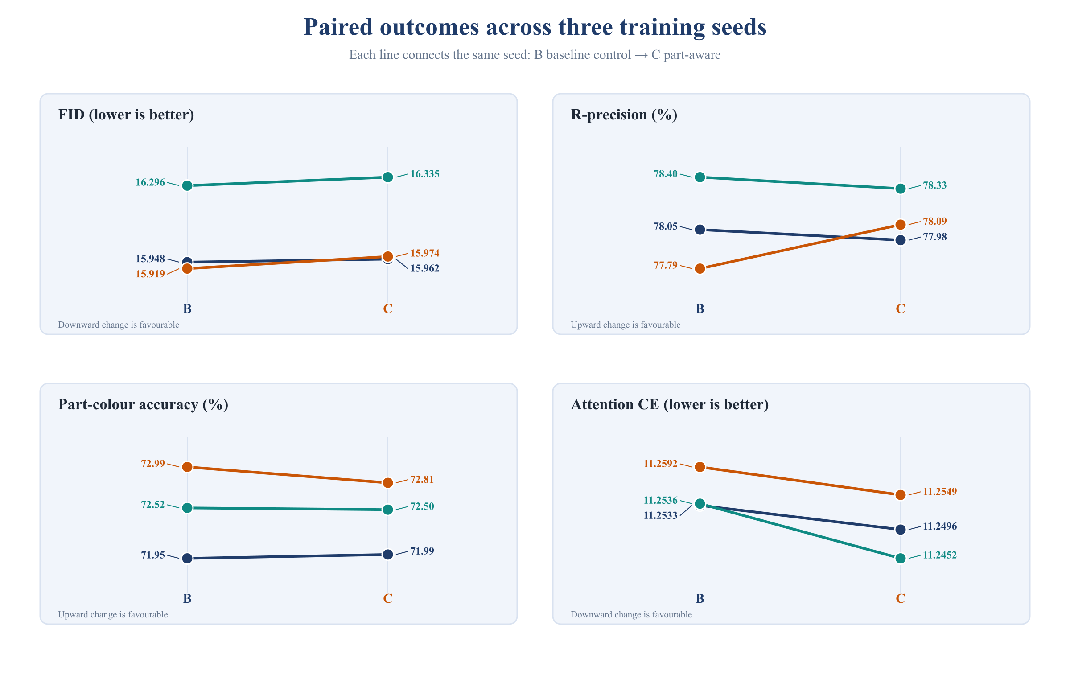
Figure 2. Absolute paired outcomes for all three training seeds; no favourable seed is selected or hidden.
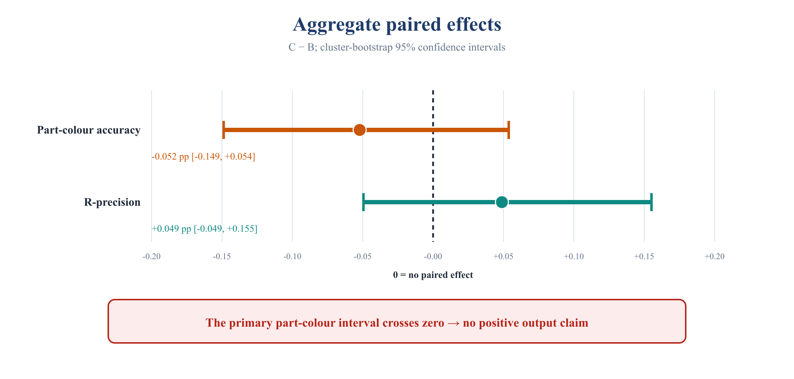
Figure 3. The primary part–colour confidence interval crosses zero, so a positive output claim is unsupported.
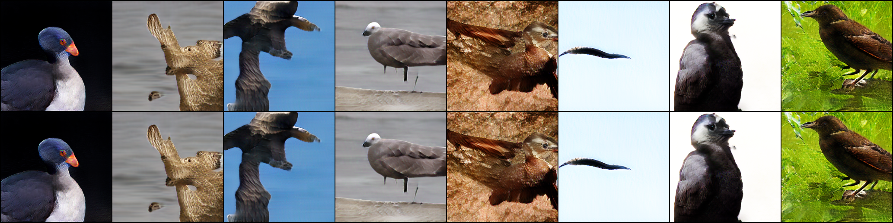
Figure 4. Complete fixed preview for seed 20260824: B on the top row and C on the bottom row, using identical captions and noise.

5. References
[1] M. Zhu, P. Pan, W. Chen, and Y. Yang, “DM-GAN: Dynamic Memory Generative Adversarial Networks for Text-to-Image Synthesis,” Proceedings of the IEEE/CVF Conference on Computer Vision and Pattern Recognition, pp. 5802–5810, 2019.
[2] C. Wah, S. Branson, P. Welinder, P. Perona, and S. Belongie, The Caltech-UCSD Birds-200-2011 Dataset, California Institute of Technology, Technical Report CNS-TR-2011-001, 2011.
[3] T. Xu, P. Zhang, Q. Huang, H. Zhang, Z. Gan, X. Huang, and X. He, “AttnGAN: Fine-Grained Text to Image Generation with Attentional Generative Adversarial Networks,” Proceedings of the IEEE Conference on Computer Vision and Pattern Recognition, pp. 1316–1324, 2018.
[4] M. Heusel, H. Ramsauer, T. Unterthiner, B. Nessler, and S. Hochreiter, “GANs Trained by a Two Time-Scale Update Rule Converge to a Local Nash Equilibrium,” Advances in Neural Information Processing Systems 30, 2017.
[5] I. J. Goodfellow et al., “Generative Adversarial Nets,” Advances in Neural Information Processing Systems 27, 2014.
[6] H. Zhang et al., “StackGAN: Text to Photo-Realistic Image Synthesis with Stacked Generative Adversarial Networks,” Proceedings of the IEEE International Conference on Computer Vision, pp. 5907–5915, 2017.
[7] T. Salimans et al., “Improved Techniques for Training GANs,” Advances in Neural Information Processing Systems 29, 2016.
[8] M. Zhu et al., DM-GAN Official Implementation and Released CUB Checkpoint Results, GitHub repository, https://github.com/MinfengZhu/DM-GAN (accessed 2 September 2026).

